TEACHING ASSISTANT KS1
AND TA KS1 MATERNITY COVER
TO START ON 3 JANUARY 2023

CANDIDATE INFORMATION PACK

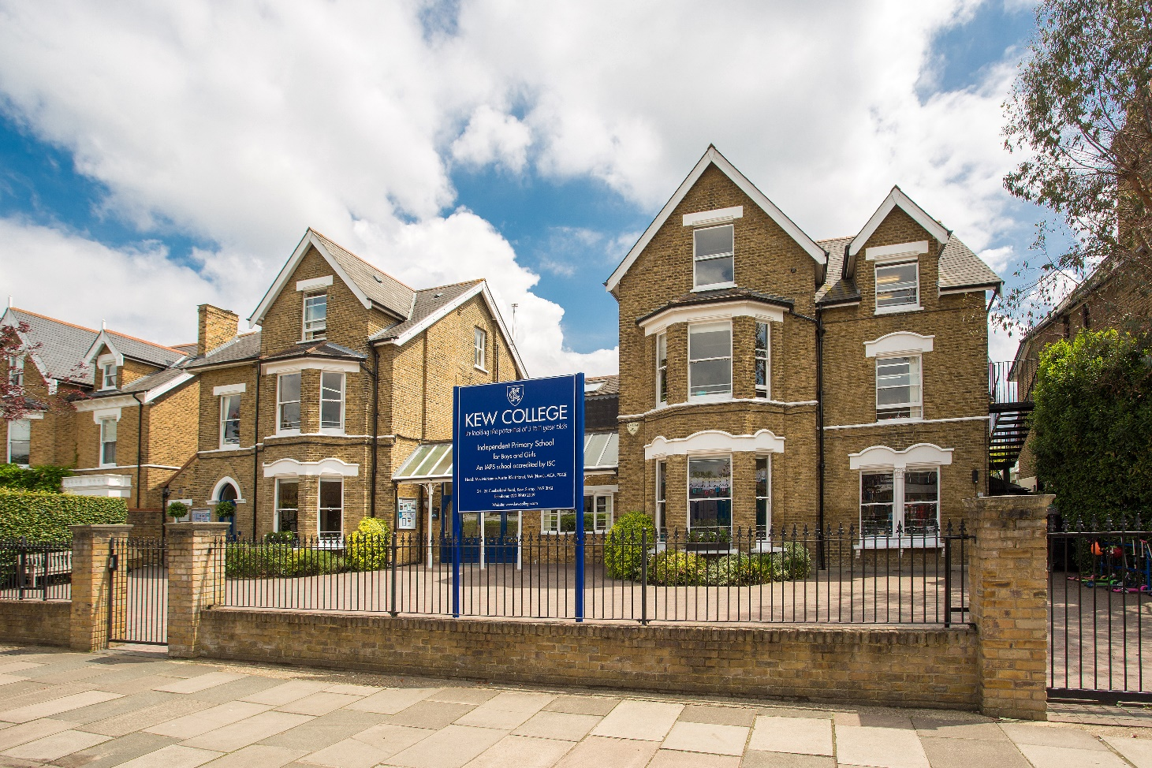
CLOSING DATE FOR APPLICATIONS: 9am MONDAY 28 NOVEMBER
PLEASE NOTE THAT WE RESERVE THE RIGHT TO INTERVIEW AND APPOINT BEFORE THIS DEADLINE SO EARLY APPLICATIONS ARE ENCOURAGED

Applications are warmly invited for the role of Teaching Assistant at Kew College. The successful candidate will work as part a dedicated and very effective team of Infant House staff.
Kew College is a nonselective, family-orientated school for girls and boys from Nursery to Year 6. The School was founded in 1927 and has been on its current site since 1953. It occupies two Victorian buildings at the front of the site housing our Middle School, Nursery and Kindergarten classes, an Octagon building at the rear housing our Infant classes, the Sedum building housing the Music Dept, Science Lab and ICT rooms and the recently redeveloped and state of the art Upton building housing the Art room and our Upper School classes. The Sedum and Upton buildings are on a separate site one minute walk away.

More importantly, it’s a happy, friendly and caring community where children, parents and staff are united by a shared set of values. Our academic record is outstanding, while our caring approach and supportive atmosphere help every child to grow in confidence and find their place in the world. Our staff work hard to ensure the potential of every pupil is fulfilled to a high level.
This important role at our school requires the successful candidate to demonstrate initiative, the ability to work autonomously and be a role model for the pupils in the class and the school as a whole, care and compassion and preparedness to go the extra mile.
The specific duties of the successful candidate will, amongst other duties, include the following:

Teaching Assistant – Job Specification
Key aims of the role:
Teaching Assistants are highly valued and essential members of our school community. They play an important part in the everyday teaching and learning experiences of our children and are an essential part of the practical and supervisory elements of the school day. Inspiring and kind TAs can make a big impact on a child’s education; we aim for all our TAs to be high quality and committed practitioners.

Role outline:
- Complement the work of teachers by providing pupils with the level and type of support required and/or by taking responsibility for learning tasks as agreed. This will involve joint planning with teachers, preparing and delivering activities for individuals or small groups
- Plan and assess work (alongside the teaching staff) and deliver pastorally focused groups, where necessary
- Deliver specific time-limited interventions in small groups or one to one
- Provide learning support for pupils in the class or in withdrawal situations, either one to one or small groups, under the guidance of the class teacher
- Support children with special educational needs and disabilities, under the guidance of the Head of Learning Enrichment.
- Provide positive reinforcements, praise, and awards
- Use ICT effectively to support learning activities and develop pupils’ competence and independence in its use
- Assist class teachers with the preparation of resources and displays
- Accompany staff and pupils on school visits
- Supervise pupils during lunch, indoor and outdoor breaks
- Take responsibility for the safeguarding, happiness, and welfare of every pupil with whom they work

Key responsibilities:
- Be a positive role model and demonstrate consistently the positive attitudes, values, and behaviour that are expected of pupils
- Establish productive working relationships with staff and pupils
- Attend and assist class teachers with assemblies
- Attend staff meetings and liaise and co-operate with colleagues on whole school matters
- Attend INSET and other training organised by the school to provide a consistent approach to teaching and learning
- Cover for absent colleagues when required
- Attend parents’ events and liaise with parents informally as appropriate
- Be accessible and amenable to regular parental contact, and develop open, easy and professional relationships with parents
- Ensure the safety and well-being of children and young people at the school by adhering to and complying with the School’s Safeguarding including Child Protection Policy and Procedures at all times
- Adhere, at all times, to Health and Safety legislation, and all departmental policies and procedures, to ensure their own safety and that of colleagues, pupils and visitors
- Carry out any other reasonable duties as requested by the Head or members of the School Leadership Team
- Constantly appraise your professional performance, participate in training courses and keep informed of current legislation and best practices in conjunction with the Deputy Head
- Be familiar with all school policies and the contents of the Staff Procedures Handbook

Responsible to:
Deputy Head
Term and Conditions:
Salary will be commensurate with experience
Working hours are 8.00am until 4.30pm daily alongside events such as Parents’ Evenings and other essential events
Pension scheme. Salary Sacrifice Scheme is available for pensions
Employee Assistance Programme
Cycle to Work Scheme

Kew College is committed to Child Protection and the successful candidate will be required to obtain an enhanced DBS Certificate through Kew College, prior to starting work. Kew College upholds and promotes British values.
This job description contains an outline of the typical functions of the job and is not an exhaustive or comprehensive list of all possible job responsibilities, tasks, and duties. The job holder’s actual responsibilities, tasks, and duties might differ from those outlined in the job description, and other duties commensurate with this level of responsibility may be either permanently or temporarily assigned as part of the job.

In addition, you may be asked to undertake other such specific duties which may from time to time be reasonably assigned by the Head. Where such duties amount to more than a temporary adjustment to the main responsibilities of this job description, it should be amended accordingly.

This job description will be subject to periodic amendment whenever the appraisal process helps reveal and define significant changes in your role within the school.

Teaching Assistant – Person Specification
 | Essential | Desirable | Evidenced by
Qualifications |  | Relevant Childcare/Teaching Assistant qualification | Application and documentary evidence
Experience |  | To have worked within a similar environment as a TA or similar role | Contents of the application form  Interview
Skills | To be able to work with children in a kind and dedicated manner  To be able to work alone and to be part of a busy and focused team  To prioritise tasks successfully  To plan and to anticipate requirements  To take ownership of new projects or to manage existing ones  To demonstrate patience and empathy |  | Demo session with children  Interview  Short written task
Personal competencies  and qualities | Ability to contribute actively to school life and to understand its protocols  - To present themselves and their work in a smart and professional manner  - Motivation to work with children and young people  - Ability to form and maintain appropriate relationships and personal boundaries with pupils  - Emotional resilience in working with challenging behaviours  - Positive attitude towards the use of authority and to be able to maintain discipline  - Ability to maintain complete confidentiality and discretion as required  - High levels of professional integrity and the ability to make sound judgments under pressure | Candidate would specifically enjoy working in and contributing to a co-ed prep school, having gained some knowledge or experience already | Application Form  Interview  References

Kew College is committed to safeguarding and promoting the welfare of children and expects all staff and volunteers to share this commitment. All applicants must be willing to undergo child protection screening, including checks with past employers and the Disclosure and Barring Service (DBS). Overseas police checks will be also required if the candidate has lived in a country other than the UK for a total of 3 months or more in the last 5 years. Kew College is an equal opportunities employer.
Our Safeguarding Policy is available on our website.
HOW TO APPLY:
- Please complete our Application Form and the Confidential Disclosure form and send to Margaret Panayi at recruitment@kewcollege.com
- The recruitment process will comprise of an interview in the first instance together with a tour of the school. Successful candidates will be invited back to carry out a relevant task

